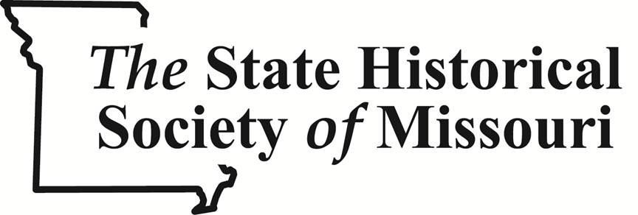
For Immediate Release
Media Contact: Mary Ellen Lohmann
1020 Lowry Street, Columbia, MO 65201
Tel: 573.884.7904 | Main: 573.882.7083
LohmannM@umsystem.edu | shs.umsystem.edu

Missouri students showcase history and gain skills through competition
COLUMBIA, Mo. April 17, 2014 – More than 3,000 motivated sixth through twelfth graders compete in National History Day in Missouri each year. On April 26 roughly 600 students who have advanced from regional competitions throughout Missouri will gather at the state competition on the University of Missouri campus to showcase their exemplary work.
Each National History Day in Missouri project is unique, a result of extensive research and creativity from an individual student or group. The program encourages young scholars to present their findings their way through documentaries, exhibits, papers, performances, or websites.
Many individuals rank the opportunity for student leadership, empowerment, and growth as one of the most important aspects of National History Day in Missouri, including Gary Kremer, executive director of The State Historical Society of Missouri (SHSMO), which sponsors the program in partnership with the Missouri Humanities Council.
“The impact on students is tremendous and well worth the investment from the Society and from teachers and parents,” Kremer said. “Students build confidence, develop their critical thinking, and learn important communication skills. National History Day in Missouri prepares them for college and beyond.”
This was the case with Sawyer Judge, a St. Louis, Mo., native.
“I grew fascinated with history and learned valuable tools for research and composition,” Judge said.
A sophomore at Cor Jesu Academy, Judge penned a research paper about the impact of the Oxford English Dictionary and advanced to the 2013 national competition after placing second at state. Each year Missouri sends 60 students to the Kenneth E. Behring National Contest in College Park, Maryland, held in June. Several students have brought medals and special prizes home, beating out hundreds of other entries in their category.
“National History Day entailed drive, hard work, and research,” Judge said. “NHD was a beneficial experience for my high school career, and I gained new insight into history.”
Stories like Judge’s illustrate the underlying fact that National History Day benefits students for years to come.
A national evaluation of National History Day found students who participate:
- Outperform their peers on state standardized tests, not only in social studies but also in reading, science, and math.
- Are better writers who write with a purpose and a real voice while marshaling solid evidence to support their point of view.
- Are critical thinkers who digest, analyze, and synthesize information.
- Gain 21st-century skills, learning how to collaborate with team members, talk to experts, manage their time, and persevere.
To get involved in National History Day in Missouri, contact The State Historical Society of Missouri at 573.882.7083.
About National History Day in Missouri
Launched in 1980, National History Day in Missouri is the state affiliate of the National History Day educational program, which has half a million participants. Over 3,000 students compete in regional Missouri competitions, with 600 advancing to the state competition held on the University of Missouri campus.
National History Day in Missouri is sponsored by The State Historical Society of Missouri, in partnership with the Missouri Humanities Council.
About The State Historical Society of Missouri
Founded in 1898 by the Missouri Press Association, the Society is the premier center for the study of Missouri state and local history. The Society, a trustee of the state since 1899, collects, preserves, and publishes materials that enhance research and support learning opportunities in Missouri studies and the history of the Midwest at six research centers around the state, with headquarters on the University of Missouri campus. Visit: http://shs.umsystem.edu
# # #

